**Exercise 15.2: Loading XML with Ajax/ jQuery**

1. Using the “index.html” and “mydata.xml” files located in “assignment 15.2” folder produce the following output using **Ajax and jQuery**. In order to produce an output similar to the figure.1 code jQuery to:

* Create a description list (<dl>) and append it to the body.
* Create <img> and assign to it a class named “bookImage”, read it’s “src” data from “mydata.xml” file. Add the <img> to a <dt>.
* Read the “title” and “description” from “mydata.xml” and add them to the <p> tags.
* Assign the class “title” to the paragraph containing the title. Add the paragraphs to a <dd> tag.

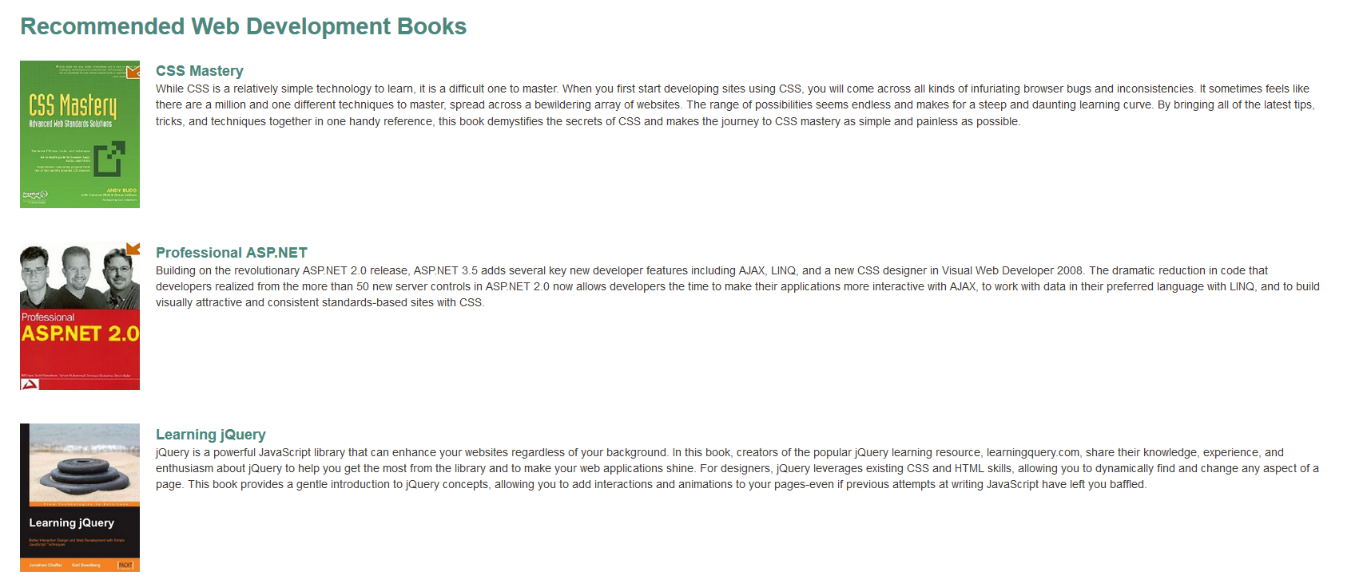Figure 1: index.html